**PF LAB 03 TASKS**

**Name: Muhammad Rohaan Roll No: 25K-0026**

**Date: 15th September, 2025 Section: BAI-1A**

**-> TASK #1:**

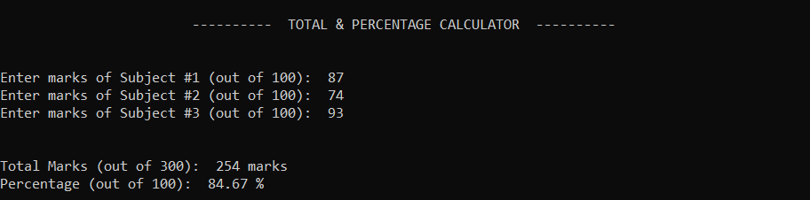

______________________________________________________________________________

**-> TASK #2:**

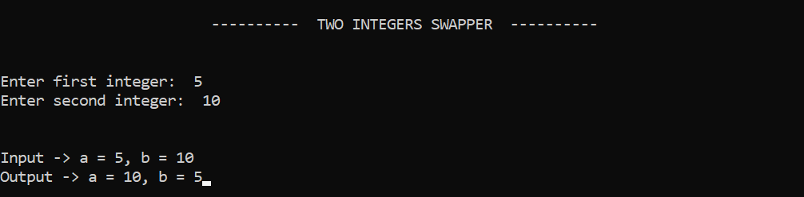______________________________________________________________________________

**-> TASK #3:**

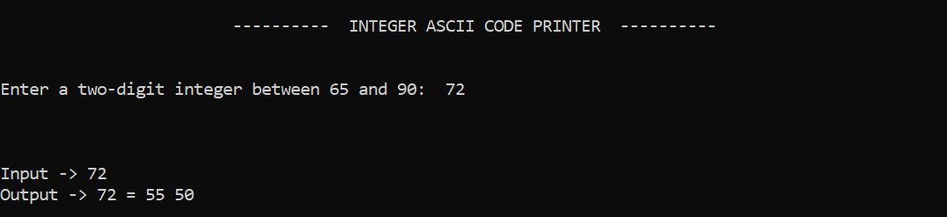

______________________________________________________________________________

**-> TASK #4:**

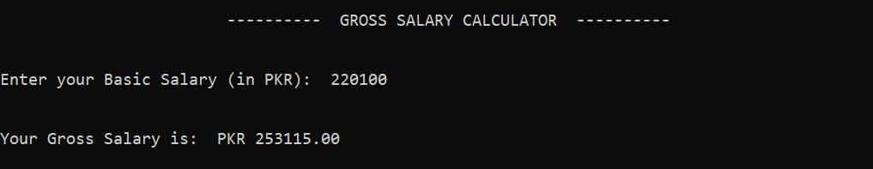

______________________________________________________________________________

**-> TASK #5:**

